Student Name: Muhammad Asim Anis Student I.D. FA19-BSSE-0032

Mohammad Ali Jinnah University

**Linear Algebra**

**Quiz 3**

**Morning Program**

**Instructor Name: Dr. Asmat Ara**

**Total Marks:10**

**Date: 9- 12 -2020 Time:**

Q#1 If *V* be the set of all ordered pairs of real numbers, and consider the following addition and scalar multiplication operations on u = *(u*1*, u*2*)* and v = *(v*1*, v*2*)*:

𝑢 + 𝑣 = (𝑢1 + 𝑣1, 𝑢2 + 𝑣2)

𝑘𝑣 = (0, 𝑘𝑣2)

1. Compute u + v and *k*v for u = (2, 1) and v = (2,4), and *k* = 2.

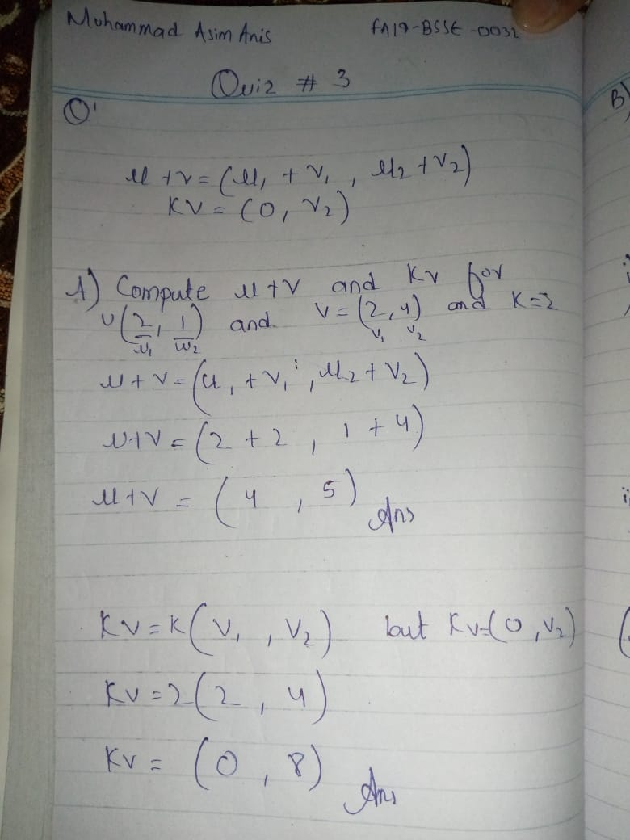

1. V is the standard addition operation on 𝑅2,certain vector space axioms hold for V because they are known to hold for 𝑅2,which axioms are they?

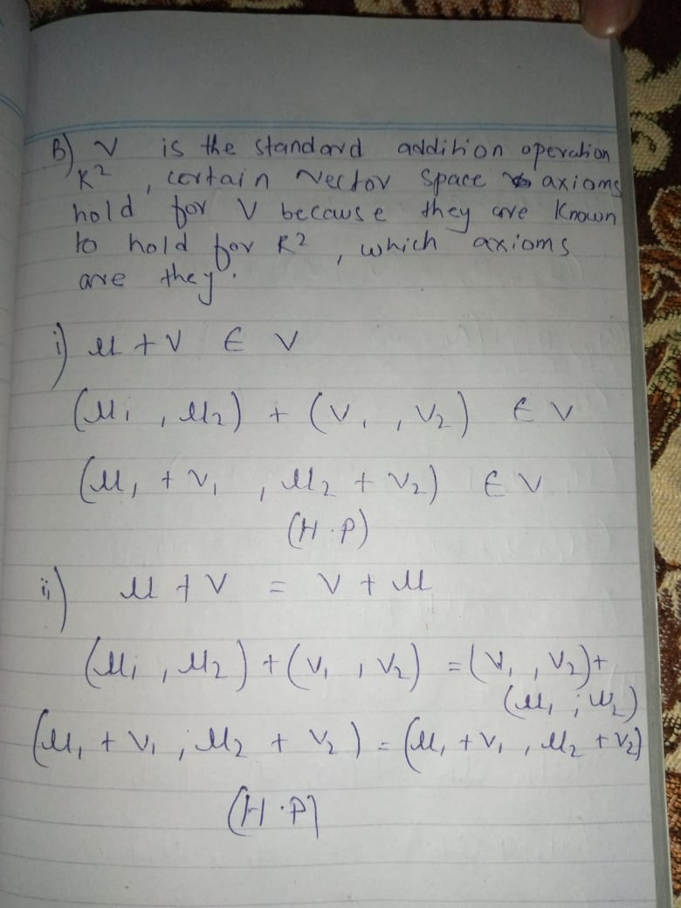

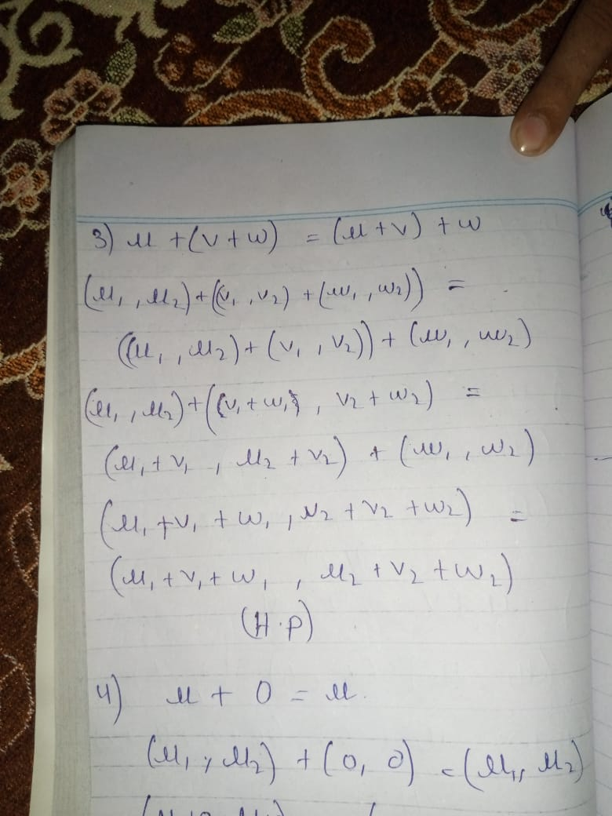

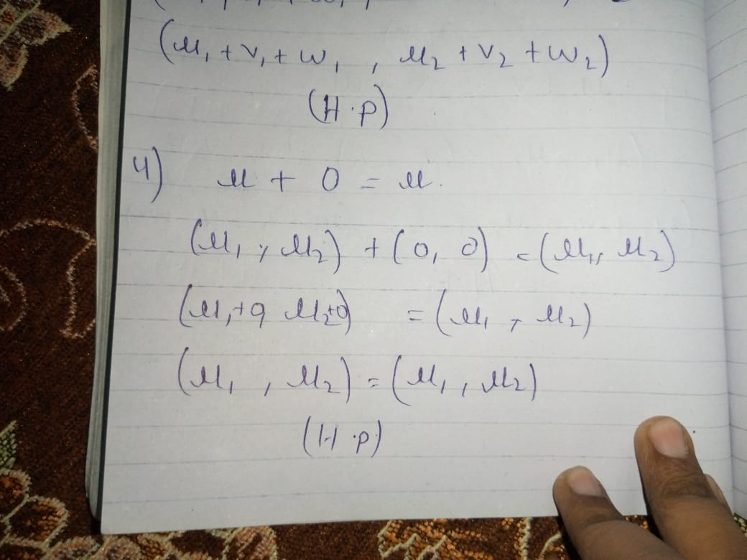

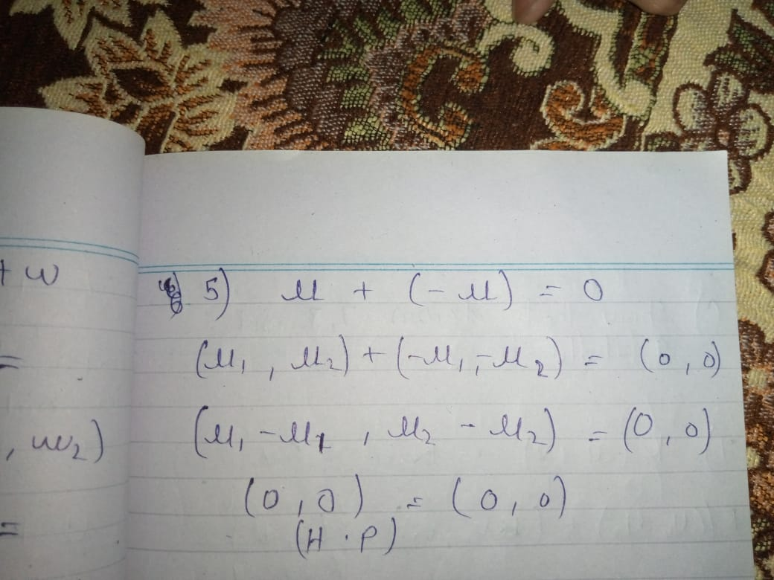

1. Show that Axiom 7, 8, and 9 hold.

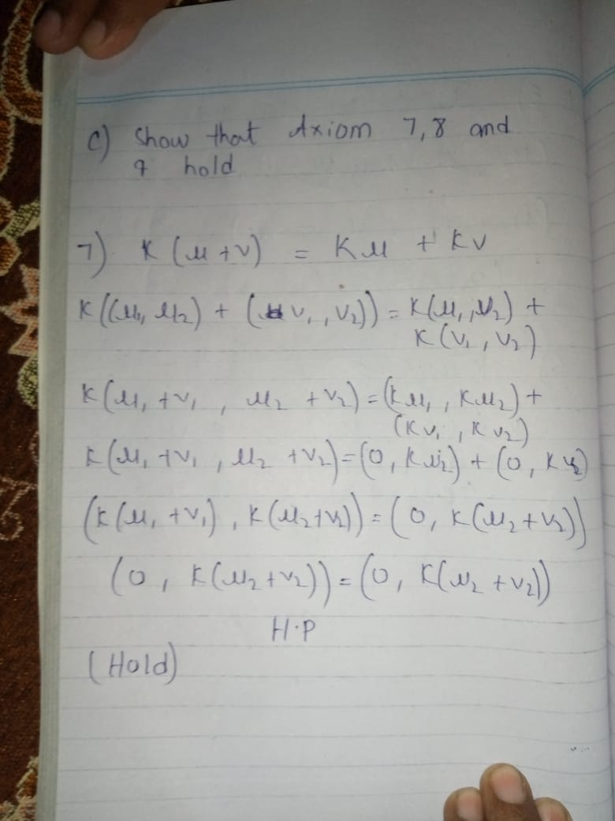

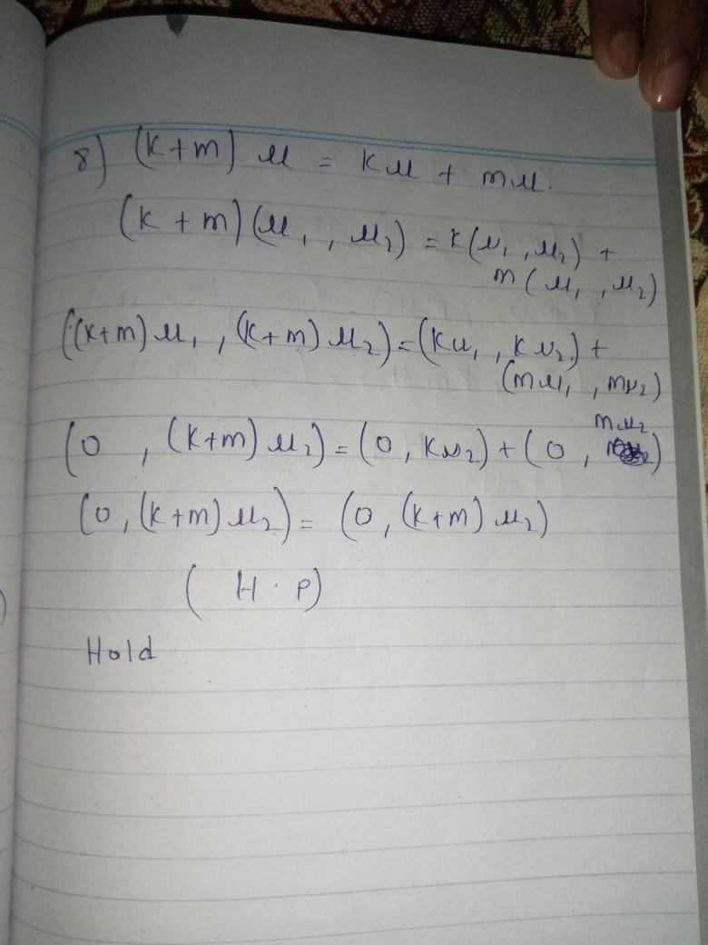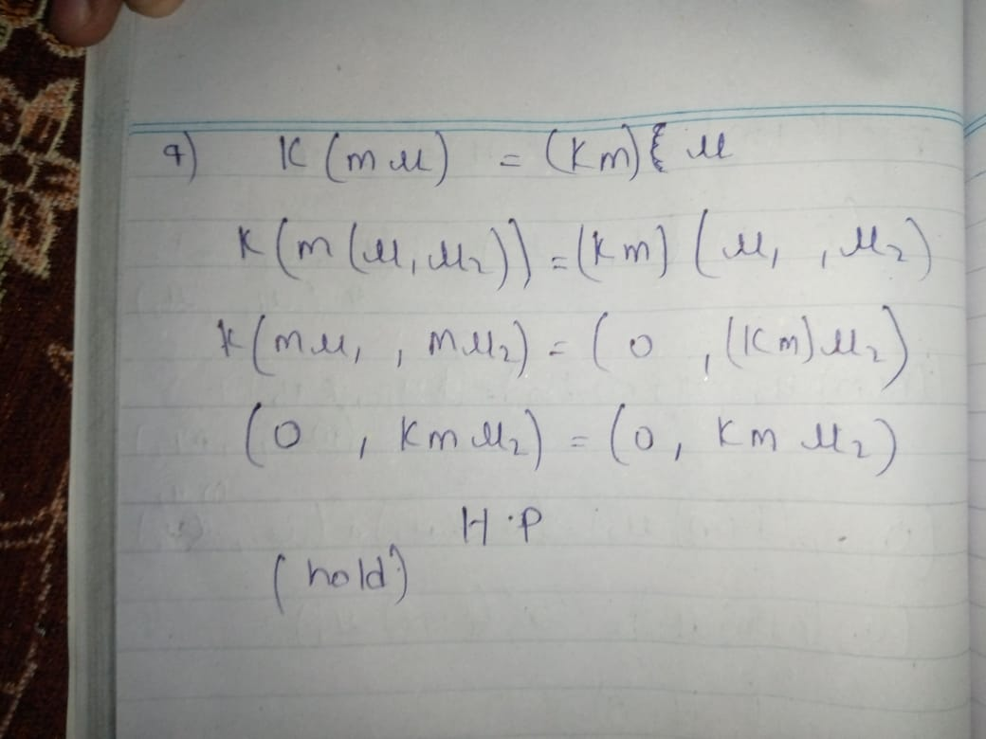

1. Show that Axiom 10 fail.

